**Installing IIS 8 on Windows Server 2012**

By [**Robert McMurray**](http://www.iis.net/learn/get-started/whats-new-in-iis-8/installing-iis-8-on-windows-server-2012#author-info)

February 29, 2012

**COMPATIBILITY**

|  |  |
| --- | --- |
| Version | Notes |
| IIS 8.0 | IIS 8.0 is only available in Windows Server 2012 and Windows 8. |
| IIS 7.5 |
| IIS 7.0 |

**CONTENTS**

* **Overview**
* **Step by Step Instructions**
* **Summary**

Overview

Server Manager in Windows Server 2012 is new and accordingly, the user experience has changed as well.

This step-by-step instruction is not unique to installing IIS. It is meant to assist IIS customers with navigating through the new Server Manager quickly.

Step by Step Instructions

**Prerequisites:**

* Windows Server 2012 has been installed.

**INSTALLING IIS 8 WITH THE DEFAULT SETTINGS**

To install IIS 8, use the following steps:

1. Open **Server Manager**. (Click on
2. Under **Manage** menu, select **Add Roles and Features**:  
   ­­­­­­­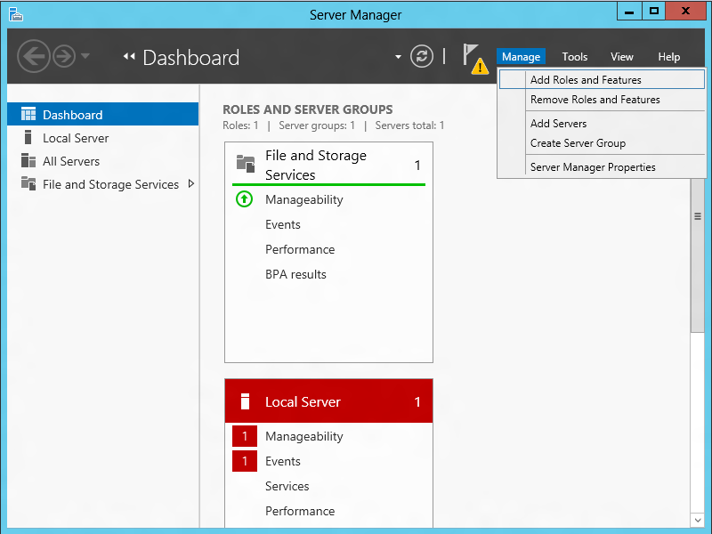
3. Select **Role-based or Feature-based Installation**:  
   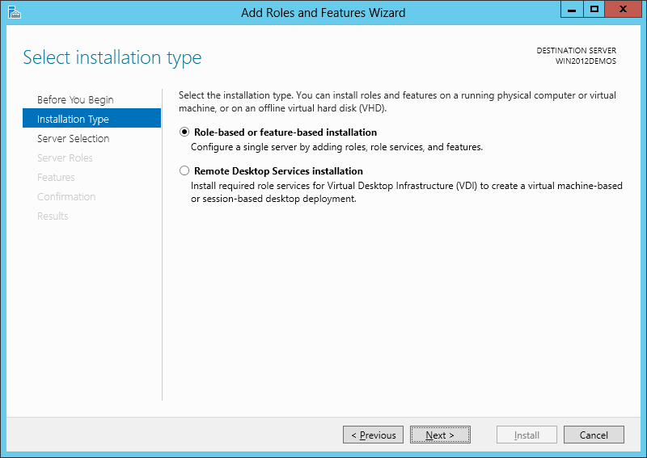
4. Select the appropriate server (local is selected by default), as shown below:  
   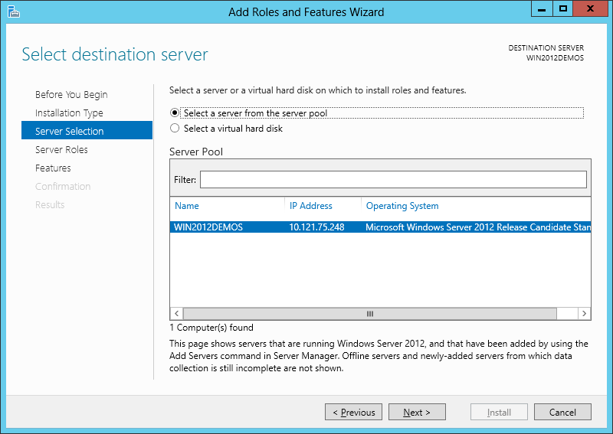
5. Select **Web Server (IIS)**:  
   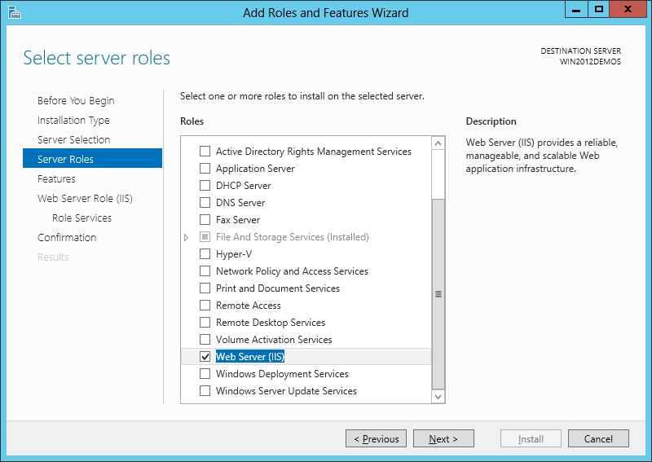
6. No additional features are needed for IIS, so click **Next**:  
   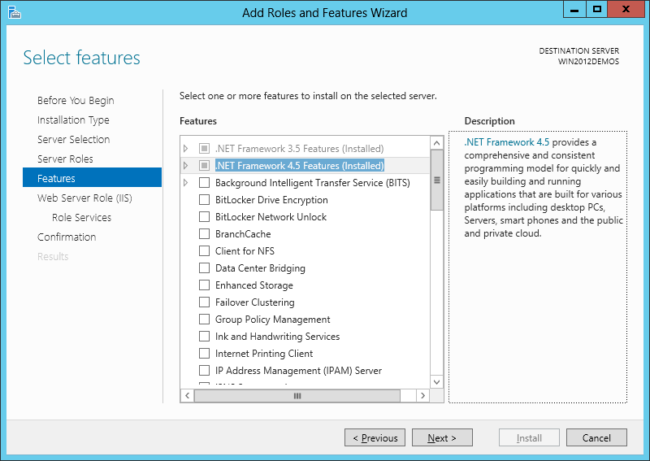
7. Click **Next**:  
   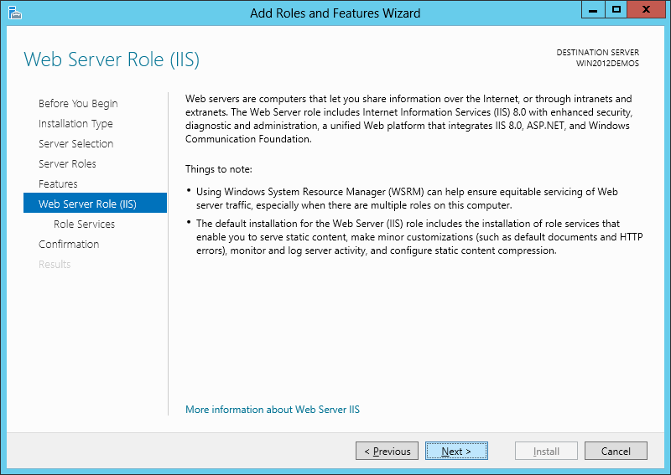
8. Customize your installation of IIS, or accept the default settings that have already been selected for you, and then click**Next**:  
   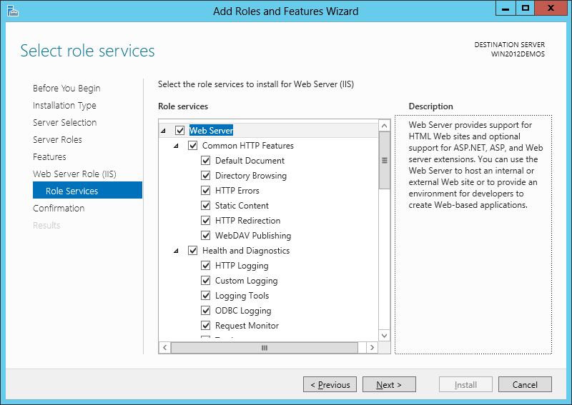
9. Check all security subsections.
10. Click **Install**:  
    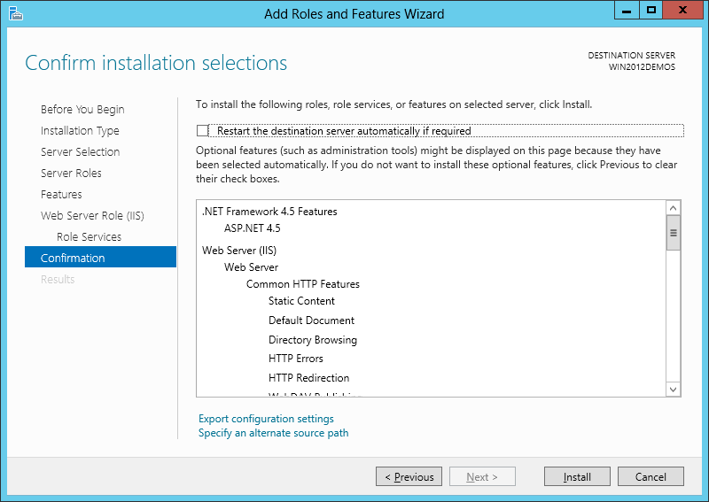
11. When the IIS installation completes, the wizard reflects the installation status:  
    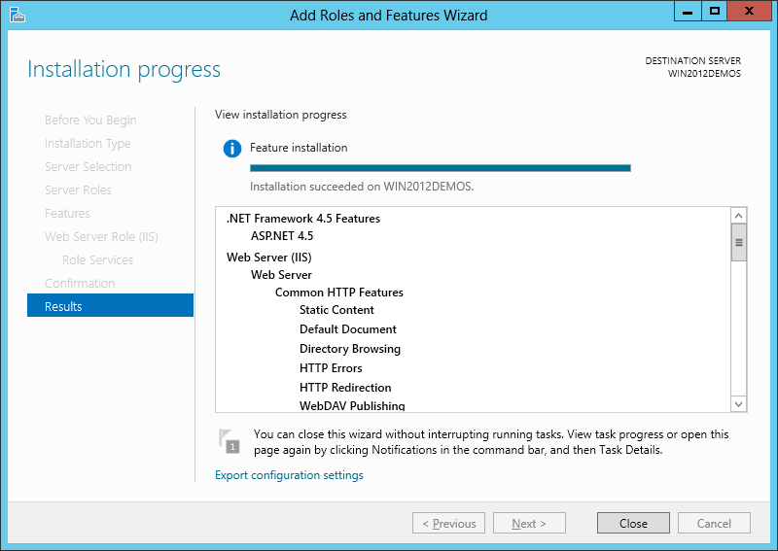
12. Click **Close** to exit the wizard.

**Managing IIS Installation:**

Click Windows button, type IIS Manager

**Windows 2013 General Administration:**

Windows 2012 don’t have start window, but Metro UI screen like in Windows 8.

Click on Server Manager button on bottom right corner, which looks exactly like :

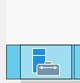

On top right Manage button for installing new services.

Tools button next to it has pretty much most of the windows admin tools are present. Like Firewall, IIS Manager, Event Viewer etc.

Security Configuration Links:

<http://www.acunetix.com/blog/articles/8-tips-secure-iis-installation/>

<https://technet.microsoft.com/en-us/library/jj635855.aspx>

<http://manual.aspdotnetstorefront.com/p-1614-enabling-windows-authentication-in-iis7.aspx>